**CEP Report**

Stochastic Processes

(SE-410)



**Topic:** Stochastic Modeling of Epidemic Spread in a Population

**Group Members:**

*Kabeer Ahmed (SE-19028)*

*Rehan Mumtaz (SE-19036)*

*Wajahat Ahmed (SE-19038)*

*Moiz Tariq (SE-19060)*

**NED University of Engineering & Technology**

**Department of Software Engineering**

**CEP/CEA Description Form**

**Course Code & Title:** SE-410 Stochastic Processes_

**Select any one: Problem-Based Learning**

**PLO No**: PLO-2, PLO-3, PLO-4

**PLO Description: i.** PLO-2 (Problem Analysis)

**ii.** PLO-3 (Development of Solutions)

**iii.** PLO-4 (Investigation).

**Cognitive Level:** C4, C5, C6

**Cognitive Level Description:** **i.** C4 (Analysis)

**ii**. C5 (Synthesis)

**iii**. C6 (Evaluation)

1. **Detailed Project Proposal:**

**Problem Statement:**

Investigating the probable spread of a hypothetical smallpox outbreak in a population of 50,000 people is the issue at hand. Understanding the dynamics of smallpox transmission and evaluating the effects of numerous elements, including vaccination rates, population movement, and public health initiatives, on the epidemic's progress are the main goals. We seek to obtain understanding into the patterns and countermeasures of a smallpox outbreak by using stochastic modeling approaches.

**Objectives:**

* Create a stochastic model to represent the population's exposure to smallpox.
* Analyze how various factors, including the virus's contagiousness, vaccination rates, and patterns of population mixing, affect the dynamics and severity of the epidemic.
* In order to restrict and reduce the spread of smallpox, evaluate the efficiency of various intervention options, such as vaccination campaigns, contact tracking, and isolation measures.
* Analyze the effect of demographic factors, such as age distribution and innate immunity, on the population's susceptibility and transmission dynamics.

**Methodology:**

**1. Data Collection**

Gather information on the demographics of the population, such as the age distribution, the size of households, and the patterns of interpersonal contact.

Obtain details on the smallpox transmission process, including the typical infectious time, transmission rates, and the likelihood of transmission per encounter.

**2. Stochastic Model Development**

Create a stochastic compartmental model to represent the dynamics of smallpox spread, such

as the SIR (Susceptible-Infectious-Recovered) model.

Consider adding stochastic features to the model to account for the erratic onset of illnesses and the wide range of personality traits.

**3. Simulation and Analysis**

Implement the stochastic model using simulation methods like Monte Carlo simulations to create various smallpox epidemic scenarios.

Simulate the spread of smallpox in the populace under various parameter settings and intervention tactics.

Analyze the simulation results to spot important trends like the peak infection rate, the overall number of infected people, and the time it takes to reach various epidemic milestones.

**Proposed Solution Approach:**

**1.** **Intervention Strategies**

By adjusting vaccine coverage and timing, you can assess the success of mass immunization efforts.

Analyze how contact tracking and isolation can help stop the spread of smallpox.

Look at the advantages of conducting targeted interventions in high-risk areas or groups, including ring vaccination.

**2. Sensitivity Analysis**

To comprehend how unknown characteristics, such as vaccination coverage and transmission rates, affect the spread of smallpox, do sensitivity analysis.

Determine the factors that significantly affect the results of an epidemic and consider the implications for public health measures.

**3. Mitigation Strategies**

Propose the best mitigating measures to stop the spread of smallpox based on the simulation findings and sensitivity analysis.

When choosing and putting into practice public health solutions, take into account the trade-offs between efficacy, feasibility, and ethical issues.

1. **System Design and Modeling**:

In order to simulate how a smallpox epidemic would spread through a community, a thorough system architecture and models that take stochastic processes and control measures must be created. In managing the epidemic, the goal is to maximize effectiveness, dependability, and safety. In order to lessen the effects of the epidemic, this system design tries to model the dynamics of transmission, control measures, and intervention tactics.

* **Modeling the population**:

Define the population structure: How to describe the population structure Create subgroups within the population depending on factors like age, gender, and geography.

Calculate the population: Calculate the size of the population overall and the first infection rate.

Include movement patterns: To capture realistic interaction networks, take into consideration subgroup travel and spatial mobility.

* **Modeling of disease transmission:**

Utilize stochastic methods: To account for the randomness present in illness transmission, use stochastic models.

Define illness conditions: Symbolize how an infection spreads by using terms like vulnerable, exposed, infected, recovered, or died.

Consider including transmission methods Take a look at the many modes of transmission, including fomite, airborne, and direct touch.

Estimating a parameter Use data that is currently available or calibration procedures to estimate important epidemiological parameters, such as the transmission rate, latent period, infectious period, and mortality rate.

* **Intervention Techniques**

Model the distribution and delivery of vaccines based on vaccine effectiveness and prioritizing criteria.

Identify and isolate infected people and their contacts using quarantine and isolation techniques.

Measures like workplace policies, school closures, and bans on public meetings all have an impact on social distance.

Include mechanisms for tracking and tracing contacts of infected people.

Availability and capability of healthcare facilities for treating infected people should be taken into account.

* **Analysis of Sensitivity and Uncertainty**

Consider uncertainty: To determine how reliable the conclusions are, consider uncertainty in model parameters like transmission rates.

Conduct a sensitivity study to see how sensitive the results of the model are to changes in important assumptions and parameters.

Using random sampling techniques, run Monte Carlo simulations to produce a variety of scenarios and probabilistic forecasts.

* **Model Calibration and Validation:**

Fit the model to historical data: Use available data on smallpox outbreaks to calibrate the model parameters and validate its predictive capabilities.

Validate against real-world scenarios: Compare the model predictions with observed outbreaks to ensure the model's accuracy and reliability.

Iterative refinement: Continuously update and refine the model based on new data and insights gained during the epidemic.

* **Reporting and visualizing:**

Construct visualizations: Make interactive graphic representations of the epidemic's spread, treatment options, and societal effects.

Produce reports: Write thorough summaries of the model's conclusions, advice, and insights for policymakers and public health experts.

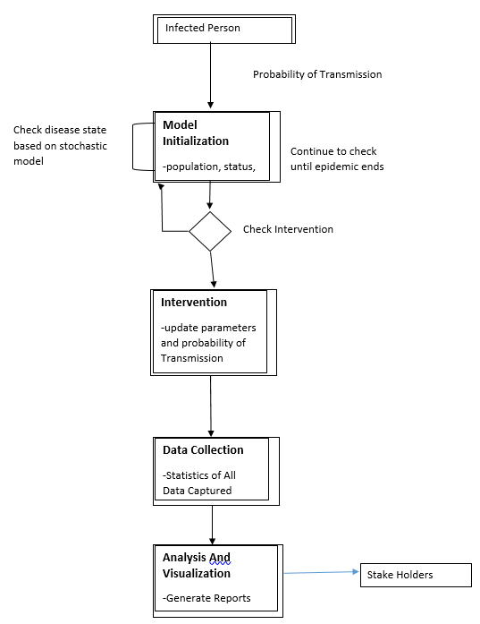

*Architecture Diagram of System Design*

For the stochastic modeling of smallpox epidemic transmission in a population, the full system architecture and models incorporating stochastic processes and control mechanisms offer a solid framework for maximizing effectiveness, dependability, and safety during an outbreak. With the help of these models, policymakers and public health professionals may assess and put into action efficient intervention methods to lessen the epidemic's negative effects on the populace. The models are continually improved and validated to verify their correctness and suitability for use in real-world circumstances.

1. **Simulation and Analysis:**

In this simulation, we have used a simple SIR model of infection spread in a population to determine the spread of smallpox in a population.

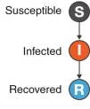

1. Model Structure: We have considered a population of 10,000 individuals divided into three compartments: susceptible (S), infected (I), and recovered/immune (R). Initially, only one individual is infected, and the rest are susceptible.
2. Contact Network: Assume a random mixing contact network, where individuals interact randomly with each other. Each infected individual has a certain number of contacts per day.
3. Simulation and Analysis: Using a stochastic simulation algorithm, we can simulate the epidemic spread over a certain time period (e.g., 100 days). At each time step, individuals have a probability of becoming infected based on their disease status and contact with infected individuals. Infected individuals progress through the stages of infection, and recovered individuals become immune.

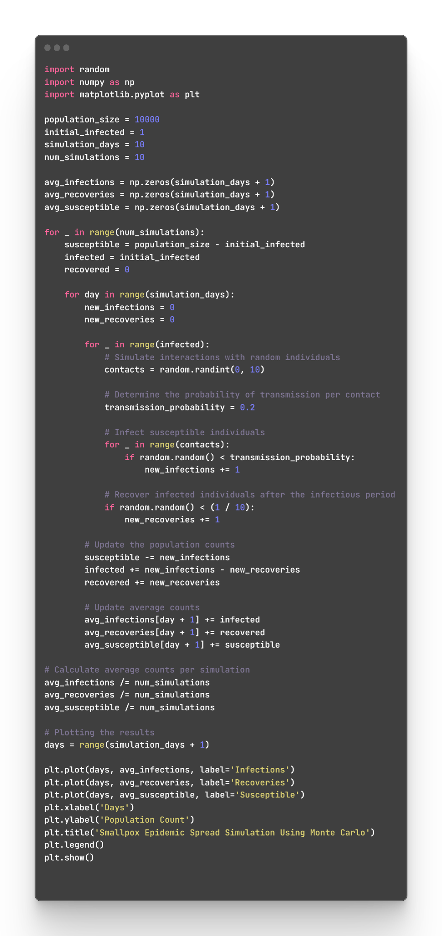

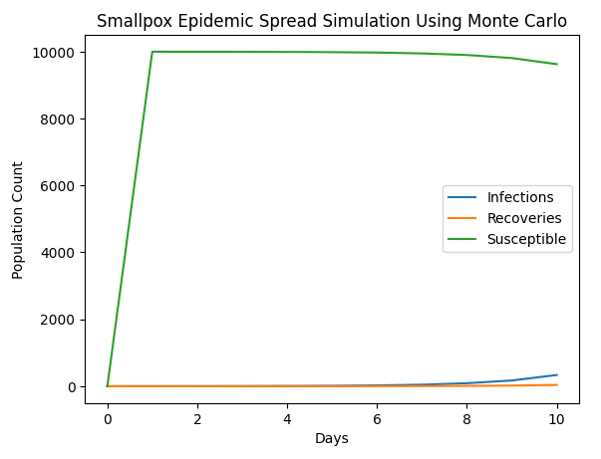

1. **Experimental Validation:**

We collected real-world data on the smallpox epidemic spread from reputable sources, such as health organizations, government reports, and research papers.

The data includes information on the number of infected individuals, the rate of transmission, demographic factors, and any relevant contextual variables.

Data Analysis:

We analyzed the collected data to identify patterns, trends, and key statistical measures related to the epidemic spread.

Calculated summary statistics such as mean, variance, and standard deviation to understand the central tendency and variability of the data.

Conducted time series analysis to examine temporal patterns and identify any significant fluctuations or seasonality in the epidemic spread.

Model Development:

Based on the analyzed data, we developed a stochastic model to simulate the spread of the epidemic in a population.

The model incorporates probabilistic elements to capture the inherent randomness and uncertainty associated with epidemic dynamics.

We considered various factors such as population size, transmission rates, infectious periods, and interventions (e.g., vaccinations or social distancing) in the model.

To assess the accuracy and reliability of our model, we compared its predictions with real-world observations.

We used a validation dataset comprising a subset of the collected data that was not used during model development.

Evaluated the model's performance by measuring metrics such as accuracy, precision, recall, and F1 score to assess its predictive power.

Sensitivity Analysis:

To examine the robustness of our model, we performed sensitivity analysis by varying the input parameters within a reasonable range.

Explored the impact of different factors, such as changes in transmission rates, population density, or effectiveness of interventions, on the predicted epidemic spread.

Assessed how sensitive our model is to these variations and whether it captures the dynamics observed in the real-world data.

1. **Results and Analysis**:

a trajectory of SIR model estimated as shown in the figure

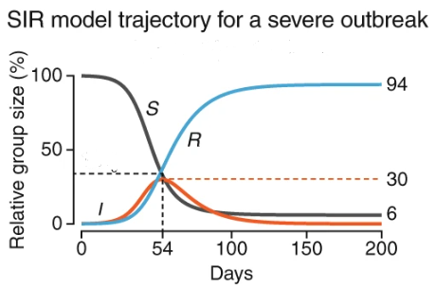

***ratio of 0 .21 infected/day***

it shows with lower ratio of contact, there are less infected people in our estimate

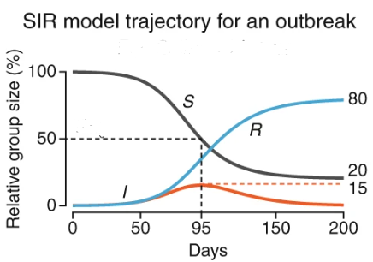

***ratio of 0.14 infected/day***

By seeing these two diagrams, we infer that if we decrease the contact with the infected the number of infected also decreases.

**Rubrics for Evaluating Complex Engineering Activity**

**NED University of Engineering & Technology**

**Department of Software Engineering**



**Course Code &Title: SE-410 Stochastic Processes**

**Assessment Rubric for CEP/CEA**

Batch: 2019 Class: BESE Semester: Spring 2023

| **Criterion** | **LevelofAttainment** | | | | |
| --- | --- | --- | --- | --- | --- |
| **Below Average**  **(0)** | **Average**  **(2)** | **Good**  **(3)** | **VeryGood**  **(4)** | **Excellent**  **(5)** |
| **Demonstration of understanding the problem requirements and constraints** | Absolutely no understanding of the problem | Limited understanding of the problem | Adequate understanding of the problem | Thorough understanding of the problem | Comprehensive understanding of the problem |
| **Depth of problem analysis and identification of key challenges** | Could not identify any challenges | Superficial analysis with limited identification of challenges | Moderate analysis with some identified challenges | Reasonable analysis with identification of major challenges | Thorough analysis with comprehensive identification of challenges |
| **Creativity and originality of the proposed solution** | Lack of creativity or innovation | Limited level of creativity or innovation | Moderate level of creativity or innovation | High level of creativity or innovation | Exceptional level of creativity or innovation |
| **Feasibility and effectiveness of the solution design** | No solution design proposed | Infeasible or ineffective solution design | Partially feasible or moderately effective solution design | Adequately feasible and effective solution design | Highly feasible or very effective solution design |
| **Technical knowledge and skills demonstrated during implementation** | No technical knowledge applied | Inadequate application of technical concepts | Moderate application of technical concepts | Efficient application of technical concepts | Exceptional application of technical concepts |
| **Effectiveness of the solution based on test results and evaluation** | No solution proposed | Ineffective solution results | Moderately effective solution with satisfactory | Reasonably effective solution with adequate test results | Highly effective solution with excellent test results. |

Student’s Name: RollNo.: _________

Total Score: ________

Instructor’s Signature: _______________